ENCRYPTED EDGE LABS CYBERSECURITY ANALYSIS INTERNSHIP
TASK REPORT

BY:

STUDENT EMAIL ID: samfelix15@gmaiL.com

Task 3- Introduction To Linux Commands

SECTION A : Command Line Navigation

COURSE INTRODUCTION:
Linux is a powerful and versatile operating system that has become a stable in the world of computing. One of the features that makes Linux more powerful is the command line interface. The CLI allows users to operate with the operating system using text-based commands.
Linux commands are the foundation of interacting with the Linux operating system. This introduction covers the essential commands, syntax, and concepts necessary for navigating and managing Linux systems, as well as their contributions to cybersecurity.

COURSE OBJECTIVES:
The objective of this report is to help
Gain familiarity with the Linux file system and master essential commands for directory exploration
Learn how to create, copy, move, delete files, and manage file permissions
Gain experience in viewing, editing, and manipulating text files using Linux commands and text editors.
Gain foundational knowledge of Linux systems by exploring key concepts, commands, and configurations in Linux environments. Develop hands-on skills to effectively navigate and troubleshoot Linux-based systems, which are crucial for cybersecurity professionals and system administrators.
Key Command Concepts:
Basic Commands: cd, pwd, ls, mkdir, rm, cp, mv.
Among these basic commands, below list the vital and must know commands to be able to build on adding more arguments. They include,
pwd: Display the current working directory.
cd: Change directories, e.g., cd /etc to move to the /etc directory.
ls: List the contents of the current directory. Use ls -l for detailed
File Permissions: chmod, chown
User Management: useradd, userdel, passwd
Process Managements: ps,kill, bg, fg
Networking: ping, ssh, scp
Package Management: apt-get, yum
Text Editing: nano, vim
File Editing: touch, cat, echo
Below is a screenshot (FIG1.1) of a terminal showing a successful navigation of the Linux pwd, cd, ls commands
FIG 1.1

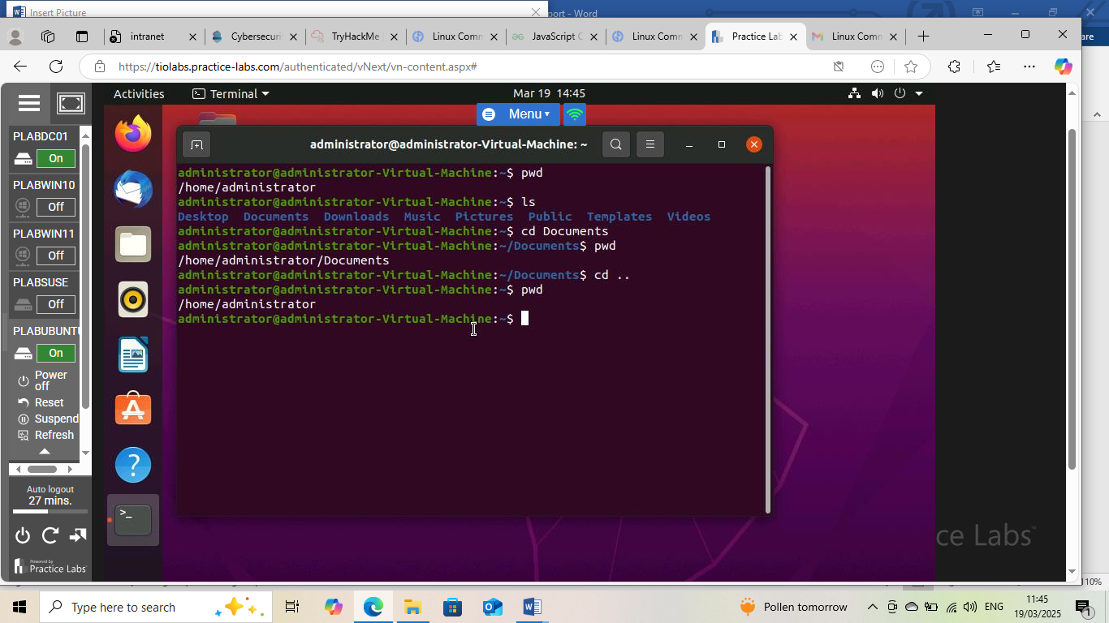

SECTION B: File Operations
Linux file operations enable efficient management of files. Key operations include creating files with touch, deleting with rm, copying with cp and moving with mv. Additionally, viewing file contents is possible with cat.
Below includes screenshots (FIG 1.2) and (FIG 1.3) of file creating, moving, copying deleting, and permission changes using chmod and chown in a Linux environment.
FIG 1.2
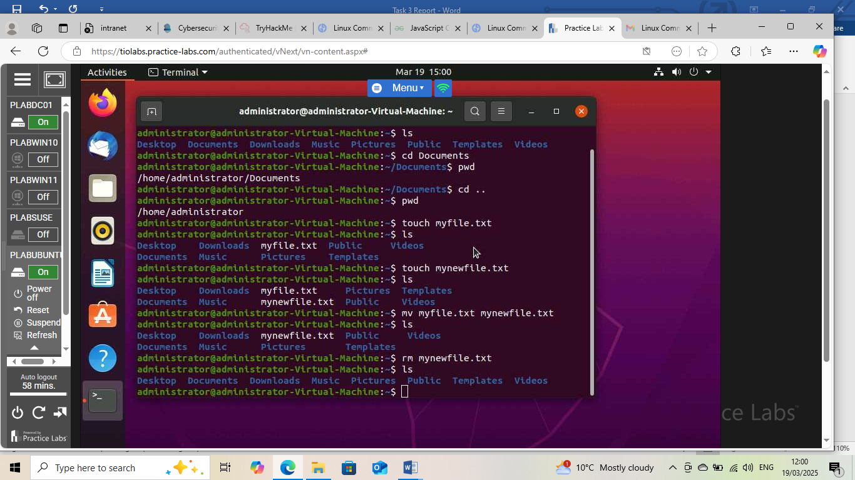

FIG 1.3
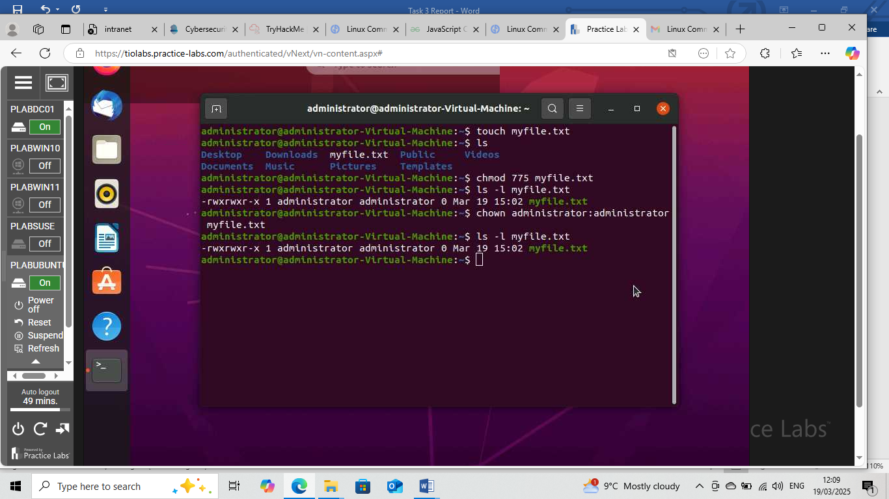

SECTION C: Text Manipulations
Linux provides various commands for text manipulation, enabling efficient editing, searching, and formatting of text files. To create and edit files, users can utilize commands like nano, vim, and echo. For viewing file contents, cat, less, and more are available. Searching for specific text patterns can be done using grep. Replacing text is accomplished with sed, while extracting specific text segments is possible with cut and awk. Additionally, text can be sorted with sort and duplicates removed with uniq. These commands facilitate a range of text manipulation tasks in Linux. (Fig 1.4) below displays screenshots demonstrating text manipulation commands and file editing using nano

FIG 1.4

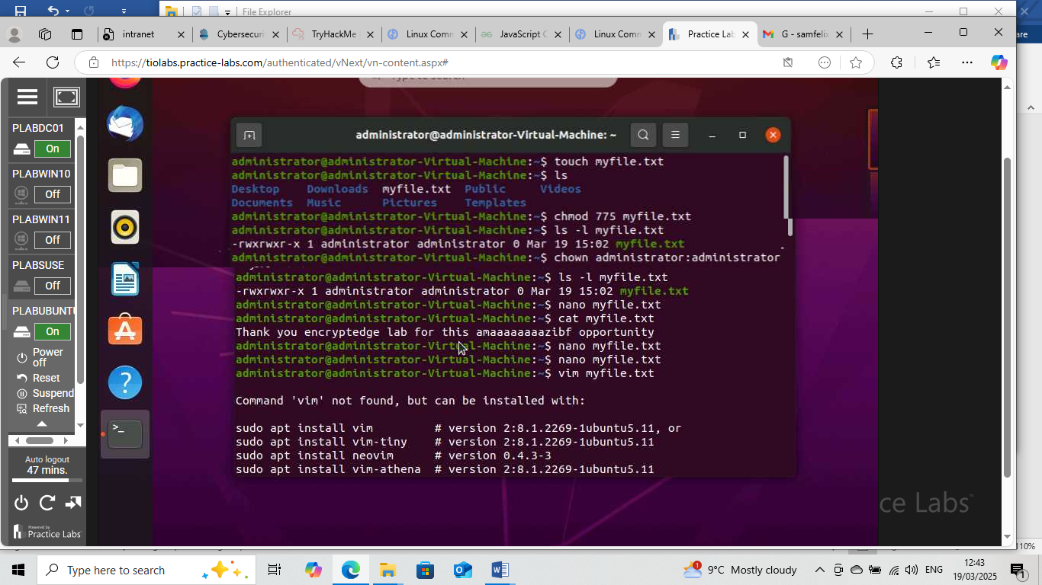

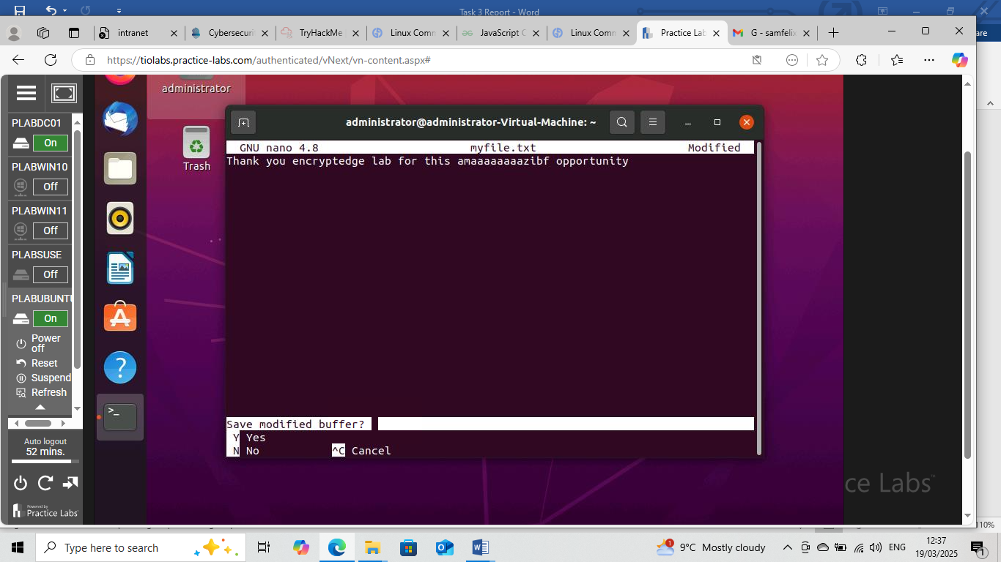

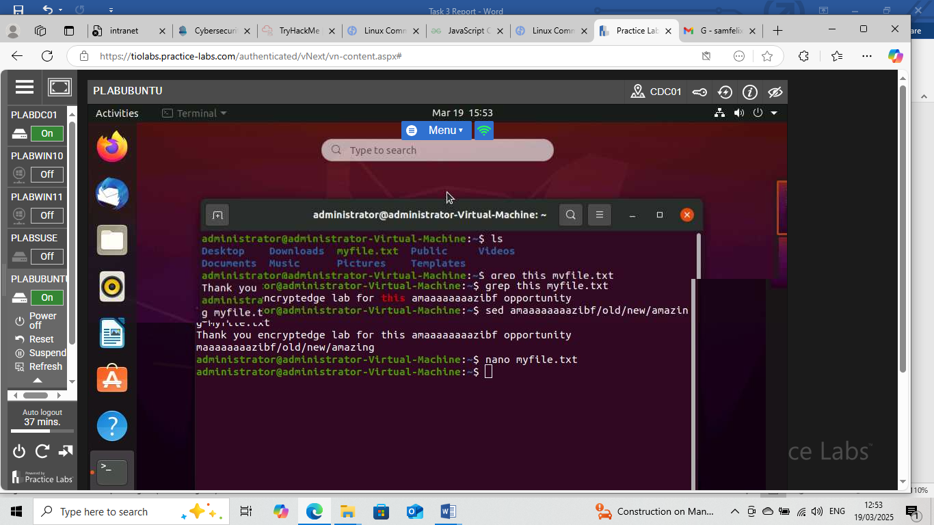

SECTION D:

This section contains screenshots of completed pages from the TryHackMe Linux fundermental labs.

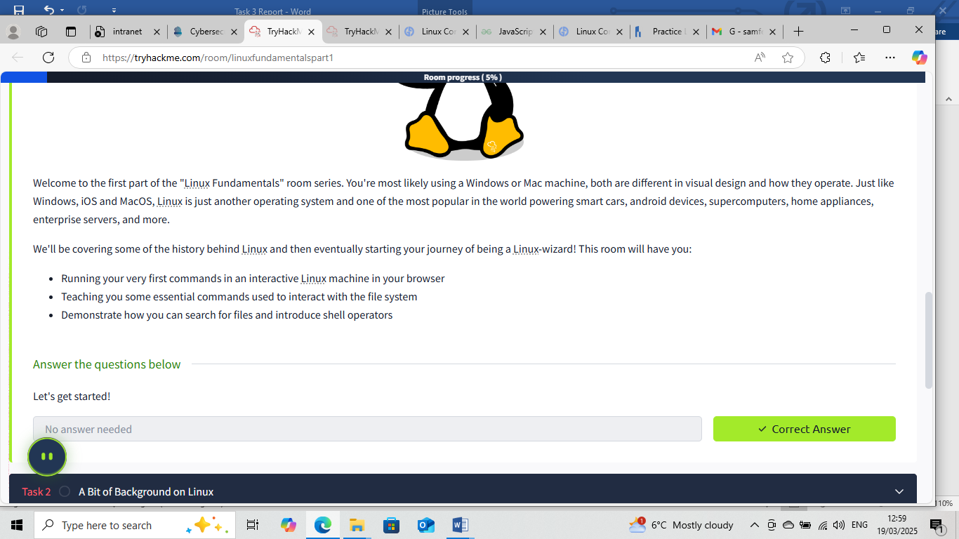

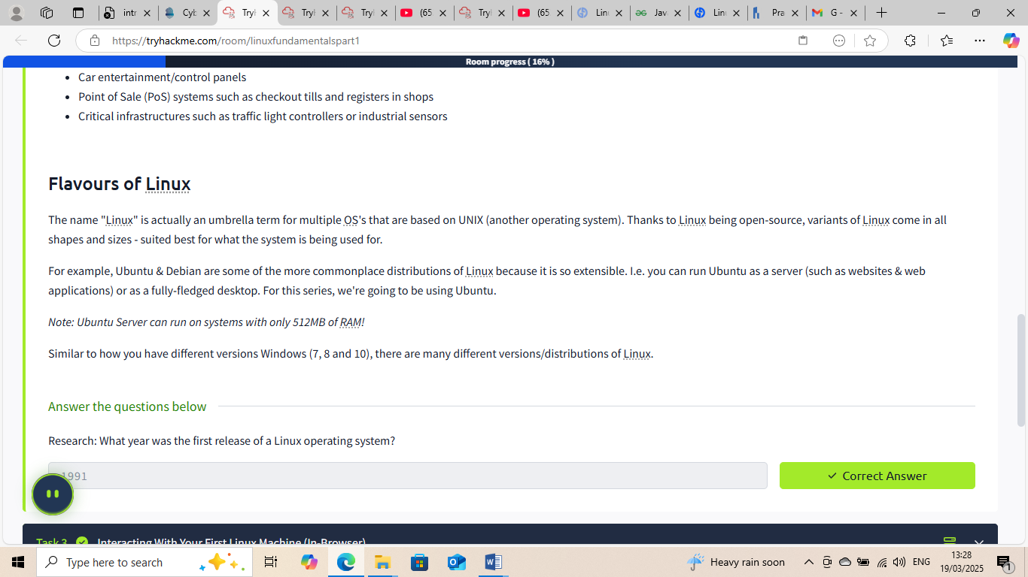

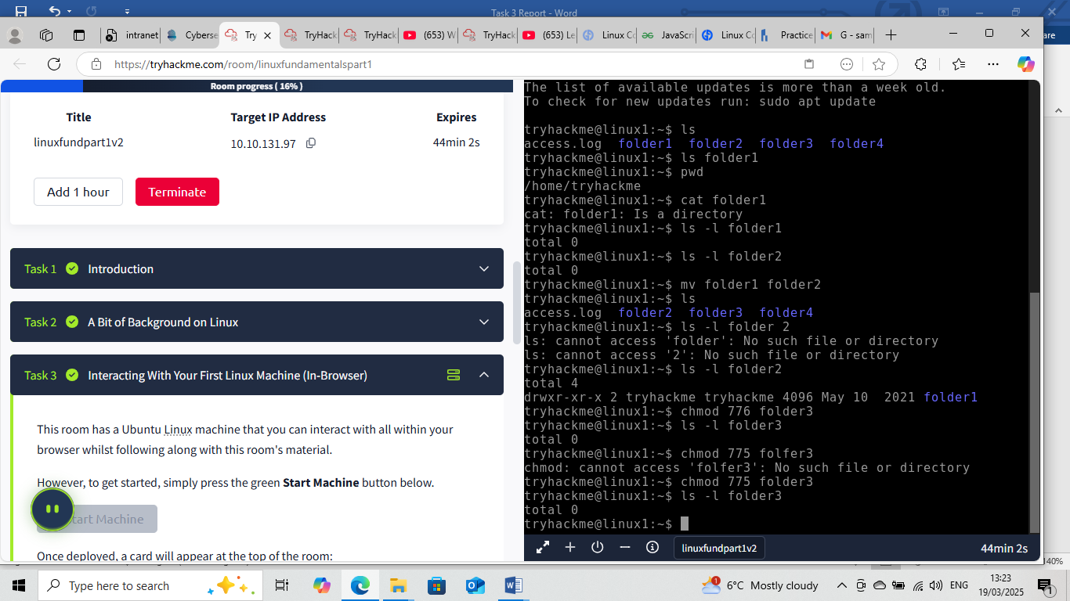

SUMMARY

In a nutshell, I have come to a comprehension that Linux distro play a very major contributing factor in everyday cybersecurity. Some of these major contribution factors includes,
System Hardening: Linux commands help configure and secure systems by modifying file permissions, managing user accounts, and configuring network settings.
Threat Detection and Response: Commands like ps, netstat, and tcpdump aid in identifying and responding to potential security threats.
Incident Response: Linux commands facilitate incident response activities, such as collecting logs, analysing network traffic, and containing breaches.
Compliance and Auditing: Linux commands help ensure compliance with security regulations by enabling the tracking of system changes, monitoring user activity, and analysing system logs. Penetration Testing: Linux commands are used in penetration testing to simulate attacks, identify vulnerabilities, and test defences.
Understanding Linux commands and their applications in cybersecurity enables professionals to effectively manage and secure Linux systems, detect and respond to threats, and ensure compliance with security regulations.

THIS INTERNSHIP TASK REPORT WAS DEVELOPED ON
March,19 2025
BY:
SAM, FELIX

